Programme to include:
Film screening
Ruby Colley Hello Halo
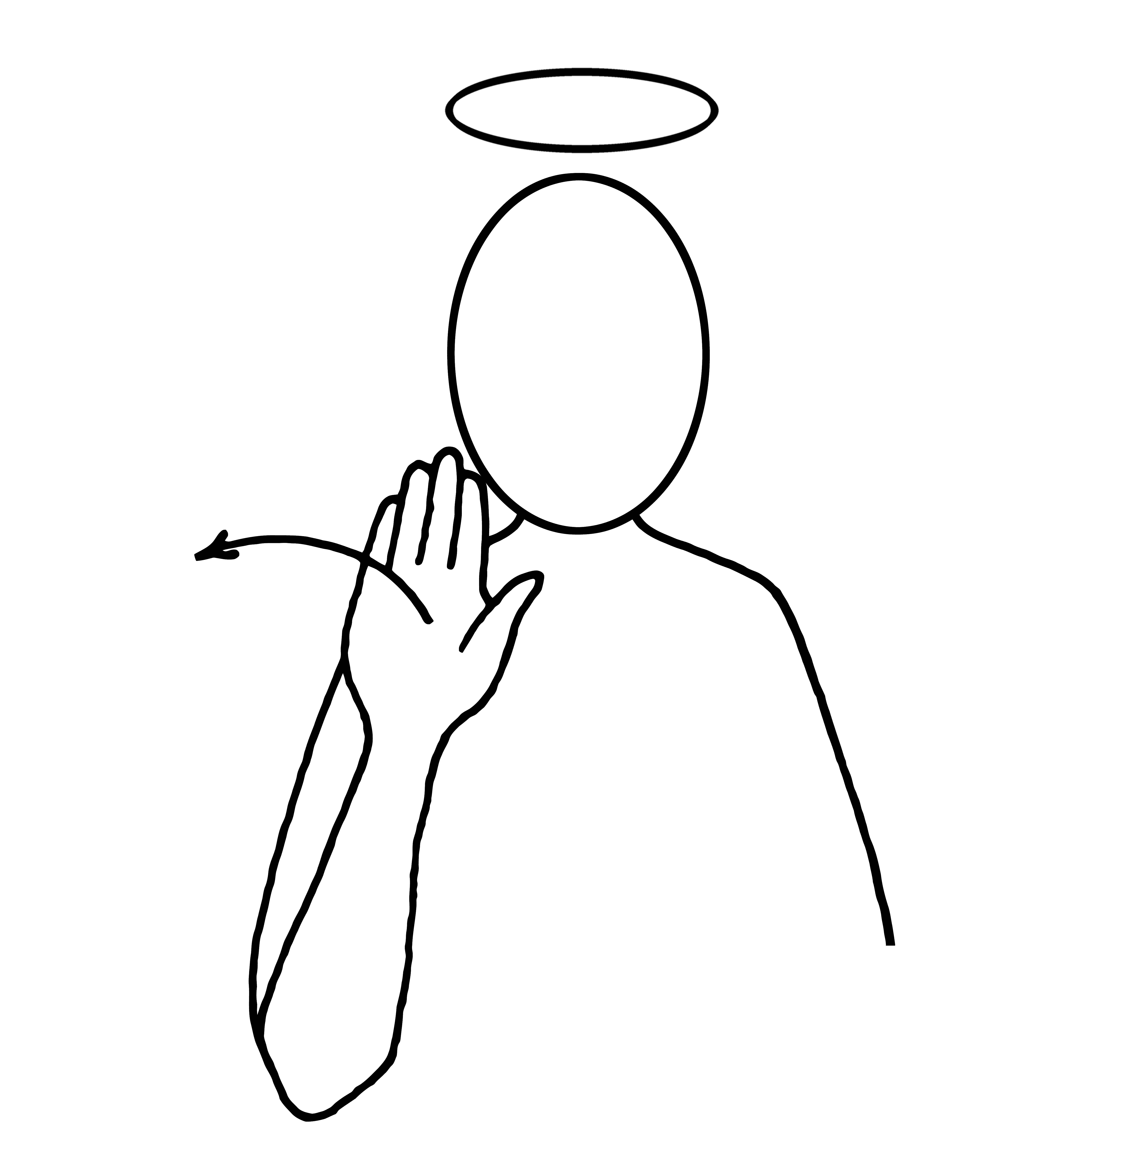
SEO text:
The Composer, Violinist & Sound artist Ruby Colley, shares her new vocal work ‘Hello Halo’ inspired by her non-speaking brother’s modes of communication performed with Exaudi Ensemble.

Ruby Colley Violinist and sound artist Exaudi Ensemble
Copy about show: This relaxed matinee performance will open with an exclusive preview of a film by Rod Morris, documenting the process of Hello Halo, giving audiences a view into the world of Paul Colley & this unique collaboration with his sister, Ruby.

A film

